Dear Customer,

Thank you for your interest in the Osbon ErecAid System, Vacuum Enhancement Device (VED). The Osbon ErecAid System is a medical quality VED, recommended for men with Erectile Dysfunction (ED). It has long been acknowledged as an effective aid for rehabilitation of the penile blood vessels. ED is a medical problem affecting thousands of men globally, every day. The ErecAid System is a non-invasive and affordable treatment option for men with ED.

The Osbon ErecAid has been manufactured in the USA for over 40 years; it has been available in Australia for 28 years; and it has a 95% success rate. It is approved by the Federal Drug Administration (FDA) in the USA; is CE Certified (a quality certification in Europe); and is approved by the Therapeutic Goods Administration (TGA) in Australia. It is a medical quality vacuum device.

A recent change to the product line has seen the USA Manufacturer, Timm Medical Technologies, merge with the PosTVac VED product range. The better performing PosTVac Battery model has now replaced the Osbon Battery model. PosTVac offers the same quality standards, is made in the USA, CE Certified and TGA Approved. All models are manufactured from the same facility in the USA.

We now offer the following three Medical Quality VED options for your consideration:

- Osbon ErecAid Esteem Manual System - This is our most popular model, and the one which suits the majority of men. Well known as being the best Manual VED on the market. Its ease of use, one-handed operation, quiet precision vacuum, easy action ring loader and streamlined use, makes it our best seller. If you have enough manual dexterity to squeeze a simple hand lever, you will be fine with this model.

Included in the cost are User Guide, cylinder, 2 cylinder inserts, quiet manual hand pump, Osbon Easy Action Ring-Loader, 4 varying Osbon tension rings and a tube of water-based lubricant. This is all neatly packed into tailor made case with foam cut-outs, to protect the unit when not in use.

- A 5 Year warranty and 90-day money back guarantee included.
- Lifetime Technical Support from our Australian Team is also included.
- The Esteem Manual System costs $654 including GST, plus $7 postage, total $661.

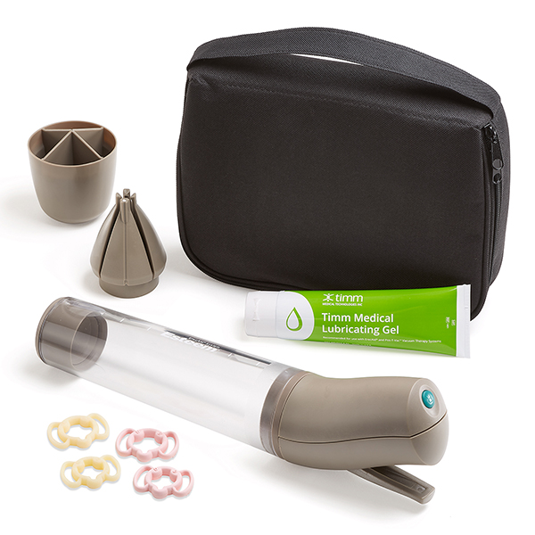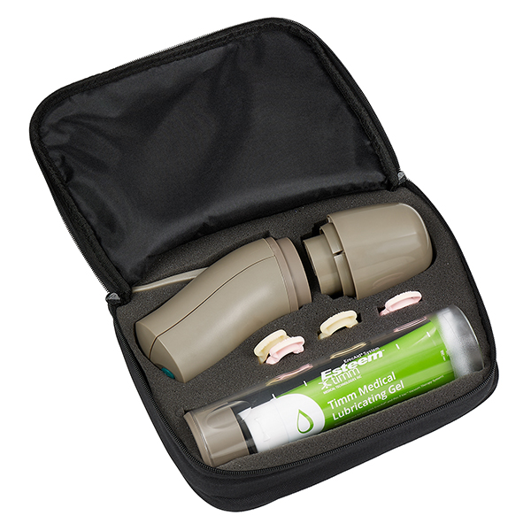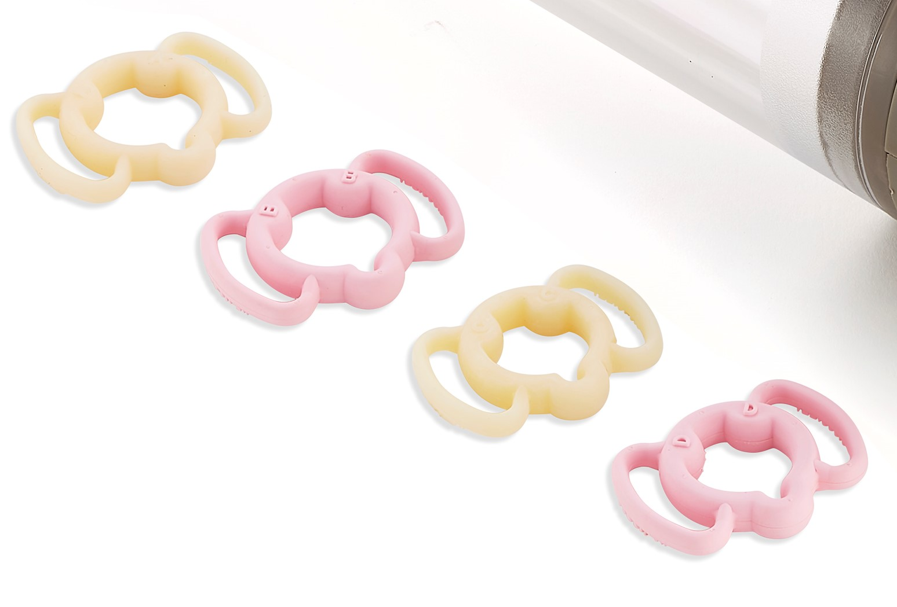
Osbon ErecAid System – Esteem Manual System with Osbon Tension Rings A, B, C and D
____________________________________________________________________________________

- PosTVac BOS3000 System – This is the PosTVac branded, top-of-the-line Battery Operated System (BOS), with 3x AA Batteries. Replaces the Osbon ErecAid Battery System. Well known as being the best Battery Operated VED on the market. Kit contains: User Guide, cylinder, 2 cylinder inserts, battery hand pump, 3 x AA Batteries, ring loading cone, 4 varying OSBON tension rings, tube of water-based lubricant, and zip carry bag (no foam insert).

Please note: In the USA, the PTV BOS3000 is supplied with PTV Mach rings. We recommend the Osbon Rings, so we have swapped the PTV rings for the Osbon Rings, A, B, C and D. If you would prefer to use the PTV Mach Rings, please let us know when you order and we will swap them for you. You can view the Mach rings on our website www.osbon.com.au, an example is also pictured below.

- A 5 Year warranty and 90-day money back guarantee included.
- Lifetime Technical Support from our Australian Team is also included.
- The PosTVac BOS3000 System costs $654 including GST, plus $7 postage, total $661.

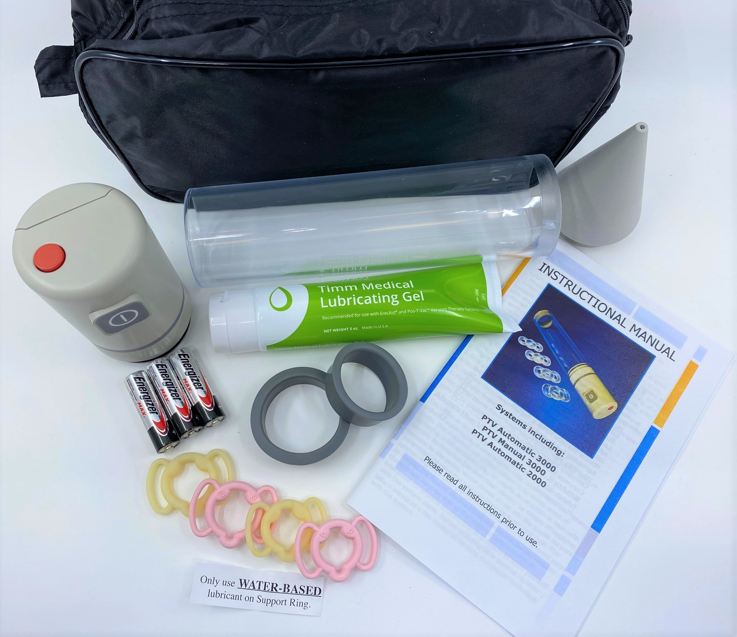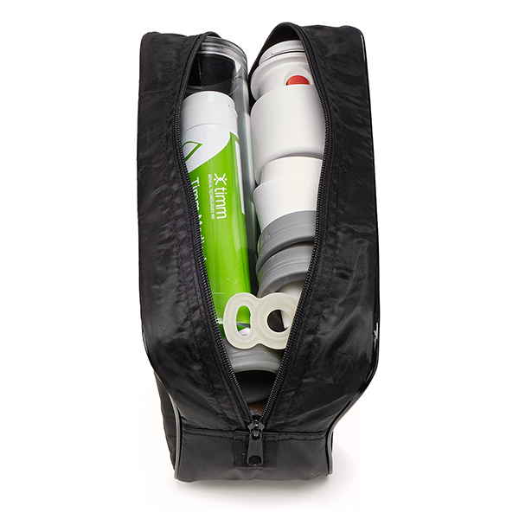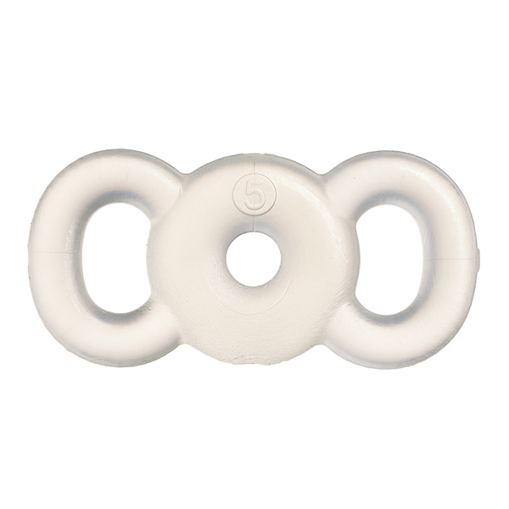
PTV BOS3000 Aus System with Osbon Rings PTV BOS3000 bag+Mach ring PTV Mach Ring
_________________________________________________________________________________________

- Osbon ErecAid Classic System – The Osbon Classic System is offered as a more affordable model. It is a manual model, but differs from the Esteem Manual System in these ways:

- The Classic is a two-handed operation (the Esteem model is a one-handed model). It has a thin flexible tube connecting the hand pump to the cylinder.
- The Classic does not have a ring loading mechanism (rings are stretched onto the end of the cylinder with fingers and thumbs). It is therefore not suitable for men with limited manual dexterity as finger strength is required. Note that the Osbon easy action ring loading mechanism can be separately purchased at another time and will fit the Classic Cylinder if you have issues loading the ring.

Included in the cost are User Guide, cylinder, 2 cylinder inserts, manual hand pump, flexible tubing, reverse coupler, 4 varying Osbon tension rings and a tube of water-based lubricant. This is all neatly packed into tailor made case with foam cut-outs, to protect the unit when not in use.

- A 1 Year warranty and 90-day money back guarantee included.
- Lifetime Technical Support from our Australian Team is also included.
- The Osbon ErecAid Classic System is $443 including GST, plus $7 postage, total $450.

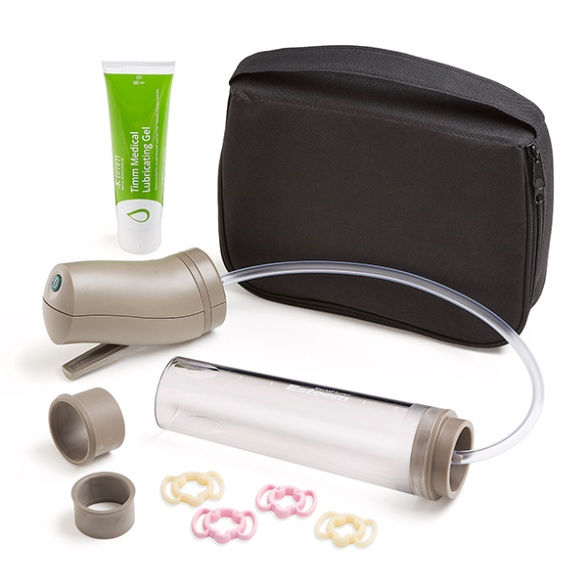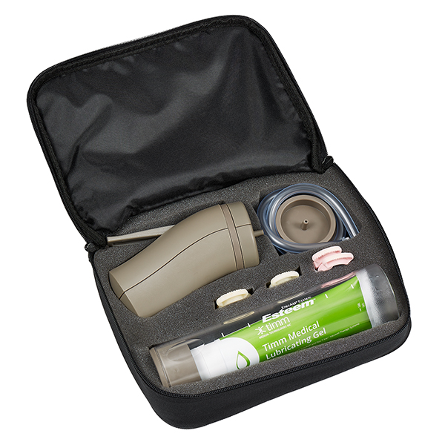

Osbon ErecAid System – Classic Manual System – with Osbon Tension Rings
_______________________________________________________________________________________
Returns: In Australia, upon purchase of an ErecAid or PosTVac System, men are supported a 90-day money-back guarantee. Our goal is to get the system working for each and every man, so we would appreciate the opportunity to provide technical support if any issues are being experienced. In the event that a patient is not satisfied with the result, he is required to receive advice via phone or email, from our technicians on a minimum of two occasions. If after acting on this advice, a satisfactory result is still not achieved, customers may obtain a refund after returning their VED system complete. We would refund the purchase price (excluding postage), less one tube of lubricant ($19) and one ring ($30). The return policy does not cover change of mind returns.

Subsidies: VEDs in Australia are not covered by Medicare in Australia. If you have private health cover, with top extras, you may find that your fund will reimburse part of the expense of the ErecAid or PosTVac, so it is worth enquiring with your fund if they will provide a reimbursement. The funds usually require a specialist referral just attesting to the medical appropriateness of the purchase.

Department of Veterans’ Affairs also fund the entire cost of the ErecAid System for eligible war veterans. Contact me if you are a Gold Card Veteran, and I can make the necessary arrangements.

Remember, the Osbon ErecAid System is very easy to use, and has worked for thousands of men, where many thought that nothing would. It works for 95 out of 100 men, and if it doesn’t, you can get your money back. Be prepared for approximately a two-week practise period, whilst you establish a good technique.

A formal prescription is not required in Australia in order to purchase an ErecAid or PosTVac. It is however important, that each patient has consulted with a medical practitioner to establish the cause of his erectile dysfunction.

We accept payment via Visa or MasterCard, or you can EFT funds into our account (contact us for account details). You can order in the following ways:

- By Phone: 1800 635 189 or (07) 5527 6311 and we will take your order over the phone; or
- By email: complete the attached order form and email it to info@multimedicalgroup.com.au; or
- Internet: www.osbon.com.au and order via PayPal or Credit Card.

Questions? Not sure which model to order? Call us and we can discuss which model would be best for you. The end result is just as effective with all three models, it is just the features vary slightly between models. Please do not hesitate to contact me with any queries you may have. We are here to help.

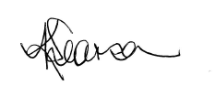
Yours sincerely
Karen Searson
Customer Support Manager 05 February 2022

